10 Truths Every Christian Should Know
You Are A Theologian by Jen Wilkin & J.T. English
Lakeside Fellowship
July 13, 2025

What is a disciple?
What is theology?
Who is God?

What is a disciple?

“Christian” - ___________; “The Way” - ______________; “Disciples” - ______________

Historical background
- The WAY” = _________________, ____________________

- Jewish educational system:
- ““House of the ______________________”
- “House of __________________________”
- Apprentice under a _________________.

- Three driving goals of the apprentice:
- To be ______________________ your rabbi
- To become _________________ your rabbi
- To ___________________ as your rabbi did

- Three driving goals of the follower of Jesus Christ:
- To be _______________________ Jesus
- To become __________________ Jesus
- To ____________________ as Jesus did

- Three conditions to be considered Christ’s follower (Mark 8:31-38):
- _______________________ self
- _________________ your cross
- _________________ Jesus.

The Great Commission:

“19 Go therefore and make disciples of all nations, baptizing them in the name of the Father and of the Son and of the Holy Spirit, 20 teaching them to observe all that I have commanded you. And behold, I am with you always, to the end of the age." – Matthew 28:19,20

What is a disciple?
A disciple of Jesus is a committed follower,___________, worshiper, servant and a witness of Jesus.

What is Theology?

“Theos” = _________________; “logos” = __________________.

Theology is the _____________ of who God is as He reveals Himself in ________________!

Two basic presuppositions for the theologian:
- The ____________ is true and that it is, in fact, our only _____________________ of truth.
- That the ________ Who is spoken of in the Bible _______, and He is Who the Bible says He is.

Five ways theology is to be done:
- _____________ – The Bible is the sole authority for faith and practice – II Timothy 3:16,17

- _____________ – “Best done on our knees asking God to awaken our hearts” Ps 119:18; I Cor 2:14

- _____________ – The theologian never struts – I Peter 5:5

- _____________ – Right theology leads to right worship! Ps 19:8; 119: 14, 103, 111

- _____________ – With help from others – contemporary church and the historic church

Several quotes from You Are A Theologian by Jen Wilkin and J.T. English …

“Theology is not done exclusively or even primarily in a classroom, it is done in everyday life” (19)

“Doing theology is the work of mind renewal for the purpose of heart transformation” (21)

“The heart cannot love what the mind does not know” (21)

Who is God?

“What comes into our minds
when we think about God
is the most important thing about us.”
A.W. Tozer

The Doctrine of the Trinity:

God eternally exists as ____ essence and _________ distinct persons: God the Father, God the Son, and God the Holy Spirit. Each person is _______ God, yet there is ______ God

The word “_______” is not found in the Bible! It is the Latin word for “three”. The Bible was originally written in Hebrew (most of the OT), Aramaic (small portions of the OT), and Greek (the NT)

The theological word “Trinity” means:
- “______________”
- “______________”

The Trinity teaches God is:
- One in _____________.
- Three in ____________.

The truth of the Trinity is shown by the Bible’s teaching that:

- There is ______________ (Deut 6:4; Isa 44:6; Isa 45:5; I Cor 8:4; I Tim 2:5)

- The one God exists in _____________ Persons:
- The ____________ is God – Romans 1:7; I Peter 1:2
- The ____________ is God – John 20:28; John 10:30; John 1:1
- The ____________ is God – John 14:16,17; Acts 5:3,4
- 1x1x1 = 1

- The Father, Son and Spirit are each distinct from one another:
- The Father _____________ the Son – John 3:16
- The Son is _____________ to the Father, even to death on the cross (Phil 2:8)
- The Holy Spirit is the sent by the Father and the Son(John 14:16,17). He is often referred to as the _________________ of the Trinity. He never draws attention to Himself; He points all glory and praise to Jesus and the Father.
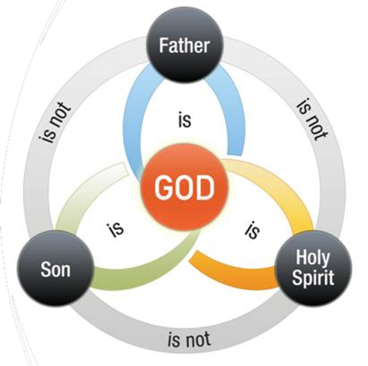

- Glimpses of the Trinity:
- First _______________ in the Bible is “Elohim” = the plural form of God (Genesis 1:1)
- Use of _____________ – God speaks of Himself as “Us” (Gen 1:26; 3:22; 11:7; Isa 6:8)
- A believer is baptized in the “name of the Father, the Son and the Holy Spirit” (“name” is singular)
- Paul’s prayer in II Corinthians 13:14 “The grace of our Lord Jesus Christ, and the love of God, and the fellowship of the Holy Spirit”
- Jesus’ _______________ to the disciples in John 14:16,17 – Jesus says He will ask the Father for the Spirit to be sent.

- Using Ephesians 1:3-14, write down the three distinct persons’ activity in salvation!

“Blessed be the God and Father of our Lord Jesus Christ, who has blessed us in Christ with every spiritual blessing in the heavenly places, 4 even as he chose us in him before the foundation of the world, that we should be holy and blameless before him. In love 5 he predestined us for adoption to himself as sons through Jesus Christ, according to the purpose of his will, 6 to the praise of his glorious grace, with which he has blessed us in the Beloved. 7 In him we have redemption through his blood, the forgiveness of our trespasses, according to the riches of his grace, 8 which he lavished upon us, in all wisdom and insight 9 making known to us the mystery of his will, according to his purpose, which he set forth in Christ 10 as a plan for the fullness of time, to unite all things in him, things in heaven and things on earth. 11 In him we have obtained an inheritance, having been predestined according to the purpose of him who works all things according to the counsel of his will, 12 so that we who were the first to hope in Christ might be to the praise of his glory. 13 In him you also, when you heard the word of truth, the gospel of your salvation, and believed in him, were sealed with the promised Holy Spirit, 14 who is the guarantee of our inheritance until we acquire possession of it, to the praise of his glory.”

